Read csv file into data frame and printed header:

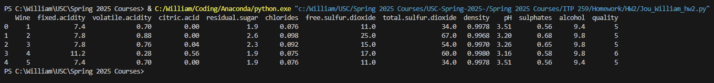

Dropped “Wine” column from data frame, printed header again:

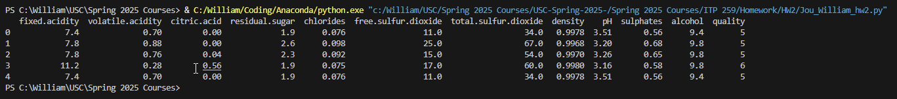

Extracted “quality” column into a stored variable, printed wine qualities:

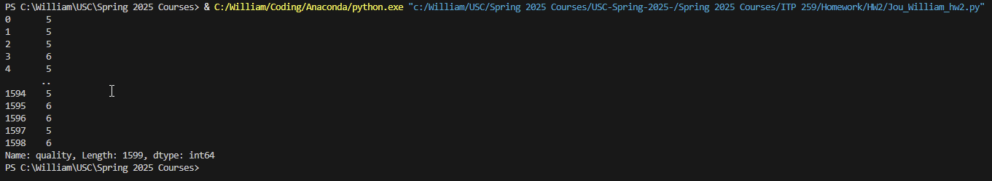

Dropped “quality” column from data frame, printed data frame: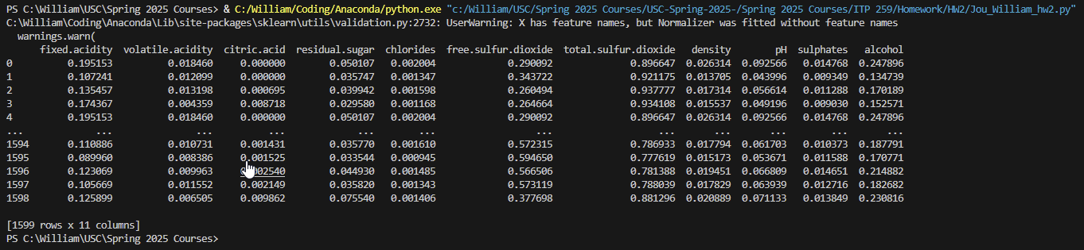

Printed normalized data frame:

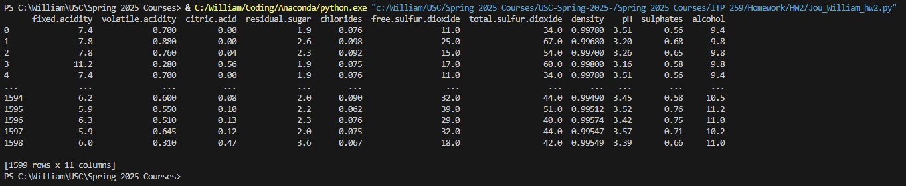

Plotting inertia vs number of clusters chart

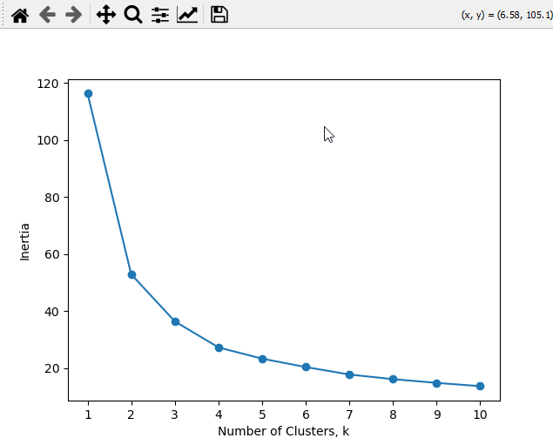

You would pick k = 5 clusters

Printing data frame showing cluster number of each wine

Printing crosstab of clusters vs quality of wine

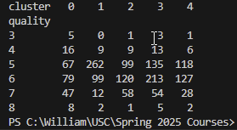

The clusters don’t seem to strongly represent the quality of wine